Peeling the informal learning
onion at STEP
by Jay Cross, jaycross@internettime.com


Hi. I’m Jay Cross and I will be joining you for STEP next month. We’re going to explore informal learning. Be informal. This will be fun. If you want to get a head start, take a look through this “cheat sheet” before we get together.

I look forward to meeting you.

What is informal learning? 2
What does it look like? 2
Global phase change 4
Return on Investment 7
Learnscaping 7
The Big Picture 8
Conversations 9
Professional Communities 10
Unconferences 10
Organizational Analysis 11
Internet Inside 12
Web 2.0 12
Learnscape Design 14
Keeping Up 17
What I’m doing these days 17

What is informal learning?
Informal learning is the way most people learn to do their jobs and to get along in the world. It’s how you learned to speak English. It’s how ten-year old children learn more about personal computers than you ever will. It’s how you learn to become a leader.

Formal and informal learning are ranges along a continuum overall, not opposites. Sometimes they overlap. Formal learning is characterized by a schedule, a curriculum, and a measure of accomplishment. It’s what comes to mind when someone mentions learning or training or education.

Formal learning is analogous to riding on a bus. Everyone starts at the same place, goes to the same destination, and arrives at the same time. This is very efficient. It’s ideal for novices who need a foundation for understanding, for learning the specialized vocabulary associated with any task, and for developing frameworks for pigeon-holing future lessons.

Informal learning is more like riding a bicycle. A person starts when he feels like it. If he sees another cyclist broken down by the side of the road, he stops to offer assistance. If he’s hungry, he may detour to a restaurant. If he chooses to shoot for another destination, he does so. The bicycle style of learning is appropriate for experienced people who have already mastered the basics. They need to fill in a few holes in their tapestry of understanding.

What does it look like?
Formal learning is classes, lectures, workshops, tests; its hallmark is that someone in authority is specifying the curriculum. Informal learning is everything else.

Informal learning in the work setting comes from asking questions, hearing stories, watching someone do a task, trial and error, searching Google, talking with the help desk, conversation in the coffee room, deciphering a process chart, hanging out with people who know, taking advice from a mentor, writing and reading blogs, and dialogue. Outside of work, you learn informally from your mother, your father, your siblings, your grandparents, and (in time) your children; your mates, your bridge partners, the people at the pub, your neighbours, television programs, gossip, old army buddies, and former classmates. Most learning is social.

Informal learning is so tightly woven into the fabric of life that it’s easy to overlook. In the early nineties, IBM was in deep trouble as a business. Then-CEO John Akers admonished workers to cut the conversation at the water cooler and get back to work. He failed to realize that talking was their work.

Informal learning is akin to intangible assets. Just because you don’t see it doesn’t mean it’s not there. By and large, informal learning flies under the radar. There’s no budget for it, no one is in charge of it, and few ever do a cost/benefit analysis.

Study after study finds that at least 80% of how workers learn to do their jobs in informal. This is a knowledge economy. Intellectual capital outweighs fixed assets. Brains trump brawn. But you’re not alone if you haven’t been paying attention to it.

80% of the corporate investment in learning flows into formal learning, yet 80% of the results come from informal learning.

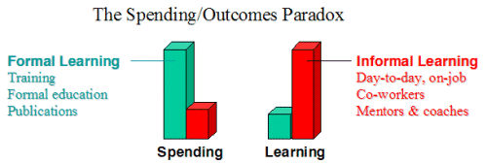

Organizations that leave informal learning to chance are leaving money on the table. They are paying no attention to perhaps the most important differentiator in the competitive arsenal.

No one is suggesting the elimination of formal learning. Rather, advocates of informal learning encourage organizations to leverage the power of informal learning by understanding it, leveraging it, and simply letting it happen.
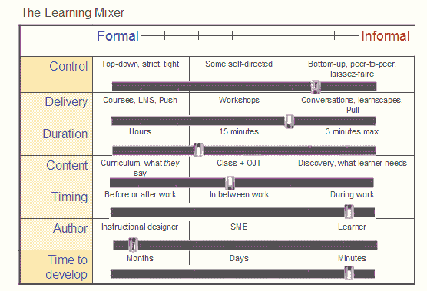

Informal and formal learning are not either/or. Rather, they are spaces on several scales. I don’t know of any learning that’s 100% formal or 100% informal.

Formal learning is generally more appropriate for novices; informal, for experienced workers. Training departments, mimicking what we saw in schools, tend to over-emphasize the formal side to the detriment of the informal. Profits are made by experienced workers; they are the ones who have been largely neglected. (How long since you enjoyed attending a class?)

Global phase change
When our children’s children look back at the early 21st century, it will seem as primitive as Neanderthals seem to us. Our world is changing fast, and the pace is picking up. Inventor and scientific sage Ray Kurzweil writes that the 21st century will contain not just a hundred 20th century-style years, but 20,000. Moore’s law applies not just to technology, but to all of human evolution.
You can almost feel the rhythm of business speeding up. New products come out ever faster. Old-style training is obsolete before it’s out the door. Everything is changing all the time.

We live in an age of networks. Networks subvert authority. Information is power, and networks give power to the people. Corporate hierarchies are crumbling, and purposeful relationship networks taking their place.

The growth and self-organization of the web are unprecedented in human history, but their major impact is yet to come. To-date, the web has largely performed as a supplier of information. Websites were one-way media, like billboards, magazines, books or television shows. Someone creates a website or resource; others look at it. The reader has little to say in the matter. This is like riding the bus of formal learning.

The web is now becoming two-way. It’s a “read-write” web. Participants can write, comment, join groups, give feedback, call up personal views of information, enlist services to alert them to events, make free telephone calls and online conferences, rate what they encounter so the good stuff rises to the top, and more. The web has become a vehicle for building and maintaining relationships. The array of options on the web is like the choices of the bike rider of informal learning.

The knowledge era rewards good thinking. Less than a hundred years ago, workers were told “You’re not paid to think.” Now workers are paid to think. As they do so, they are assuming responsibility for decisions, for working with customers, for improvising solutions, and for making their time productive.

For centuries, humankind has been accustomed to the opposite view, that knowledge is stable and can be passed along from one generation to the next, which authorities know better and are the natural source of know-how, and that workers will be more productive if they follow management’s advice rather than their own. None of these are any longer true.

The process of change has made the certainty inherent in Isaac Newton’s laws and the industrial model of organization obsolete. Today’s world is the result of the interaction of complex adaptive systems. This means that the future is unpredictable, nothing is certain, and absolute control of anything is an illusion.

The environment of business is changing from “Push” to “Pull,” that is, from the assumption that you take what you get to a world of abundance where you take what you want. Here’s a summary of this profound shift as described by John Hagel and John Seely Brown.

PUSH | PULL
Assumes you can predict demand | Assumes world is unpredictable
Anticipate | Respond
Rigid, static | Flexible, dynamic
Conform, core | Innovate, edge
Monoliths, components glued together | Small pieces, loosely joined

Change comes from the edges of an organization, not its centre. Informal learning is “bottom-up.” People closest to the action (on the edges) are the likeliest to know what to do. Giving them responsibility for generating and sharing knowledge pays respect to workers. It turns the traditional organizational structure on its head. Instead of taking instructions, workers create the future.

Organizations need to foster informal learning not just because it is profitable to do so (which is invariably the case) but because if they neglect informal learning, their goose is cooked. The goal of formal learning is “good enough.”
At Google, they say a great engineer is 200 times more effective than an average engineer. The goal of informal learning is to enable everyone to reach their full potential. Workers set their own limits.

When faced with mammoth change, as we are now, our choice is to adapt or die. There are two ways humans can adapt: evolution or learning. Evolution moves at a geological pace: we don’t have that long to wait, at least until genetic manipulation becomes a reality. Learning is our means of coping with change, and it is our route to survival and prosperity.

These changes in the world call for entirely new approaches to help workers learn to excel on the job:

OLD | NEW
PUSH | PULL
Training | Learning
Rigid | Flexible
Program | Platform
Mandated | Self-service
Formal | Informal

Return on Investment
Investing in informal learning is a profit strategy. Firms are applying informal learning to:

- Increase sales by Google-izing product knowledge
- Improve knowledge worker productivity 20% - 30%
- Transform organizations from near-bankruptcy to record profits
- Generate fresh ideas and increase innovation
- Help workers learn to learn for sustainable competitive advantage
- Improve individual learning and communications skills, maybe yours
- Reduce stress, absenteeism, and healthcare costs
- Unlock worker potential to “be all that you can be”
- Invest development resources where they will have the most impact
- Increase professionalism and professional growth
- Cut costs and improve responsiveness with self-service learning
- Improve morale and reduce turnover
- Keep pace with rapid technological change
- Replace training programs with self-sustaining communities

Learnscaping
Achieving the benefits of informal learning can’t be realized within the confines of training departments. Well, perhaps you can save a few dollars here and there, but the big payoff comes from changes in attitude and corporate culture. Informal learning is more a worldview than a specific intervention. Who’s in charge of ripping out cubicles and installing pool tables? Things like that undeniably increase informal learning but aren’t the responsibility of the chief learning officer.

Informal learning is about situated action, collaboration, coaching, and reflection, not study and reading. Developing a platform to support informal learning is analogous to landscaping a garden. A major component of informal learning is natural learning, the notion of treating people as organisms in nature. Workers are free-range learners. Our role is to protect their environment, provide nutrients for growth, and let nature take its course. Self-service learners are connected to one another, to ongoing flows of information and work, to their teams and organizations, to their customers and markets, not to mention their families and friends.

Because the design of informal learning ecosystems is analogous to landscape design, I will call the environment of informal learning a learnscape. A landscape designer’s goal is to conceptualize a harmonious, unified, pleasing garden that makes the most of the site at hand. A learnscape designer’s goal is to create a learning environment that increases the organization’s longevity and health, and the individual’s happiness and well-being.
Informal learning is holistic. “It’s not my department is no excuse for suboptimal results or stressed-out workers. Hence, learnscapes must address individuals. Helping everyone be all that they can be is not charity; it’s good business.

Gardeners don’t control plants; managers don’t control people. Gardeners and managers have influence but not absolute authority. They can’t make a plant fit into the landscape or a person fit into a team.

A learnscape is a learning ecology. It’s learning without borders. You already have a learnscape. It’s probably not all that it could be.

The Big Picture
Using visuals in lieu of words is an informal learning technique. After all, humans are sight-mammals, and we learn twice as much by appealing to both sides of the brain.

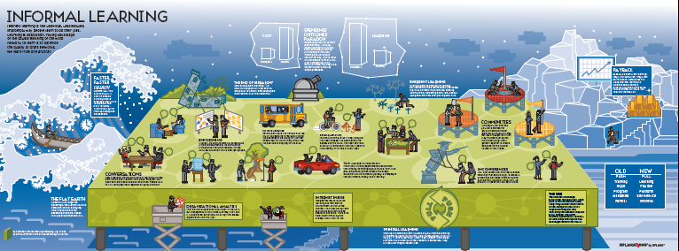

Let’s walk through a number of informal learning activities and concepts that come between the Great Wave of accelerating change (on the left) and the ascending path to greater performance (on the right). We’ll take it one piece at a time.

Conversations
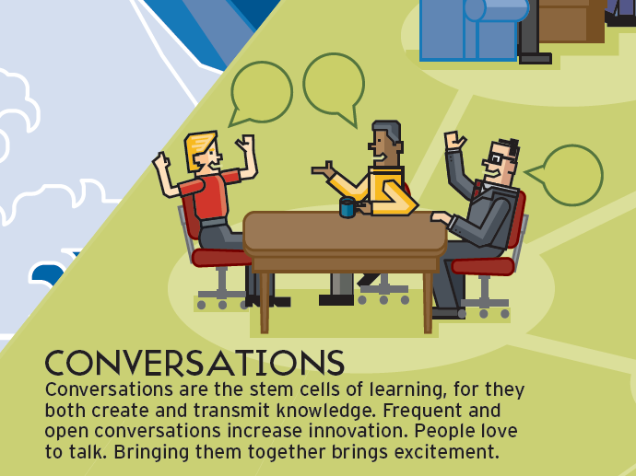

The most powerful learning technology, bar none, is human conversation. The give-and-take of humans conversing addresses both our needs and what we need to know. Conversation engages us. It shifts direction with our wishes. Credibility is built in. There is magic in it. Stifling conversation is generally a stupid thing to do. (Remember IBM’s John Akers with his “Stop talking and get back to work.”)

Facilitating meaningful conversation has the largest payback of any informal learning intervention but it’s not as simple as you might at first think. Conversations require connections, and connections imply networks. As with any network, you work toward optimization. Are the right nodes hooked up? Is the bandwidth appropriate to the task? Are there gateways to other networks?

Networks self-organize, and sometimes the best way to encourage their positive growth is to get out of the way. Several CEOs ago, Hewlett Packard asked me to talk with a group of instructional designers. I was encouraging them to get people together, so they would naturally form spontaneous communities. The designers said they didn’t know what to do. I could see out over a sea of hundreds of small cubicles. I suggested they replace a quarter of the cubicles with sitting areas with sofas and espresso machines.

Another Silicon Valley company had been pushing its twenty-four person development team really hard. The pressure had been on for months. The fact that it had relocated most of the team from Ireland, away from their families, made the situation worse. Emotions were running high. Fist-fights were narrowly averted. We set up a pool table outside the kitchen and stocked the fridge with Guinness. The team now had a place away from their computers to talk, blow off steam, and understand one another. The tension passed.

Let’s look at informal learning techniques, many of them designed to improve social connections and conversation.

Professional Communities
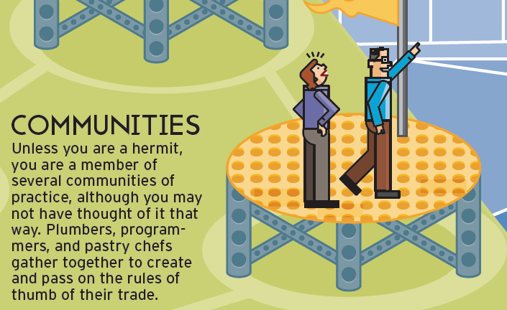

Learning is social. People learn from one another. Learning with others is human nature. Groups of people who identify with one another professionally form into loosely-structured groups quite naturally. Be they chefs or customer service reps, they converse, share know-how, help one another solve problems, use the corporate grapevine to great advantage, and help new members get up to speed quickly.

Unconferences
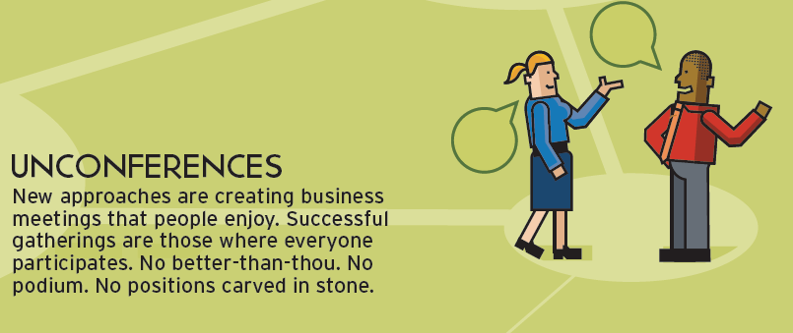

Companies and professional groups are making business get-togethers more participatory and improvisational. People attending conferences often report learning more in hallway conversations and coffee breaks than from formal sessions. Unconferences bring the talk from hallway back into the main conference room.

An unconference begins with participants suggesting topics they want to present or hear about. The hosts post an attendance list for all to see. All this is generally coordinated on a wiki.

Unconferences have a general theme but no set agenda and scant organization. Instead, the group collaboratively determines the direction of the gathering, creating an ad hoc agenda. There's an organic, self-organizing, "bottom-up" feel to unconferences, which is why they appeal to software developers, many of whom are do-it-yourself-ers.

Unconferences don’t have attendees and presenters; everyone is a participant. The assumption is that the people in the room know more than the people on the stage.

Unconferences are born from people’s desire to share and learn in an open environment. They are intense events, chock full of discussions, demos, and interaction. The wisdom of crowds supplants the wisdom of experts. They maximize value for participants, not for organizers. They are often organized is under a month and funded on shoe-string budgets. They replace slides with stories, information-sharing with collaborative learning, and instruction with discovery.

Organizational Analysis
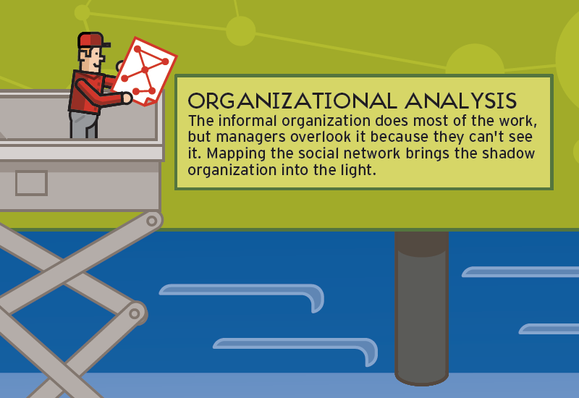

Knowledge workers waste from a third to half of their time looking for information and answers. Part of the problem comes from asking a person close-by rather than someone who probably has the right answer.

Also, since learnscaping involves optimizing connections, you need a way to spot breakdowns.

Organizations don’t run like their organization charts. The real source of information is the corporate grapevine; the real leadership comes from an undocumented cabal. Organizational network analysis, also known as social network analysis, provides an x-ray of how communications really flow and pinpoints broken or inefficient links for repair.

Internet Inside
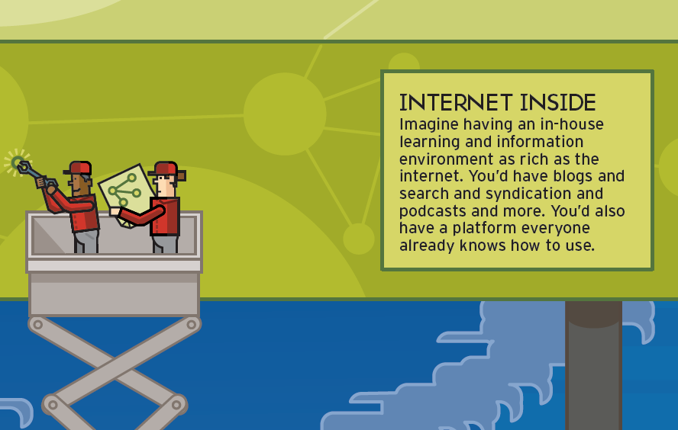

The evolution of the internet is shaping how organizations think. People understand search; they know how to communicate instantly; they expect rapid responses. Corporate information technology is becoming more web-like as it adopts service-oriented, modular, user-accessible architecture. New hires already know how to use browsers, blogs, wikis, and social software.

Corporations in the vanguard are building in-house networks (intranets) that closely resemble the web. Many of them run on variants of the same open-source software that powers the web. Web logic enables them to put systems together incrementally, swiftly, and at low cost.

Web 2.0

Nothing virtual has the impact of face-to-face communication but it’s neither cost-effective nor physically possible to bring people together in the same room for every interaction.

The structure and tools of what is called Web 2.0 fit hand-in-glove with informal learning.

Email Lists have been around for a long time but remain useful for coordinating group activities, sharing information, and archiving messages. Example: GoogleGroups.

Blogs (weblogs) are web pages that are generally created by a single individual, contain dated entries with the most recent on top, offer an option for reader to make comments, and archive past entries in a searchable database. They require next to no technical expertise to set up and maintain, and are often free. Blogs are a great way to share information.

Wikis are collaborative websites. Any member may make or change or even delete any entry. One would expect chaos and vandalism but in fact these are rare. Wikis are an ideal tool for a community building and sharing rules of thumb.

Web feeds notify or deliver changes to blogs, wikis, or other digital entities on the web to subscribers. For example, I receive a daily email with summaries of new things that have appeared on a dozen blogs I follow closely. Within an organization, web feeds could enable a group of specialists to share news and project information.

Search technology can work inside the firewall or on the open web. No more looking for the needle in the haystack.

Pod casting is like a blog in audio. Apple’s iTunes service will capture and download podcasts into an iPod although you can listen to podcasts with any digital audio player. Portability is the major benefit of podcasts. People listen to them while commuting, exercising, or walking.

Tagging is like sharing your bookmarks (or favorites) file with the world. You add informal keywords (“tags”) to blog entries or articles you save for reference. You can see mine if I can see yours. When I look at the lists of tags and tagged material of someone with whom I share interests and vice-versa, tagging becomes a social networking activity.

Digital video was out of the realm of the novice at the end of the last century. Now it has become very inexpensive and simpler. Remember that talking-head video does not teach. Video is great for building technical skills or showing scenarios.

VoIP stands for Voice over Internet Protocol. I use a service called Skype for all of my transatlantic calls and most of my domestic calls, too. If both parties are on the net, there is no charge. If I use my computer to call a regular telephone outside of my country, there is a minimal charge.

Instant messenger first became popular with school kids who wanted to stay in touch with chums while doing homework. In many corporations, IM has largely replaced email and phone calls. IM is instantaneous. I send you a message; you reply in real time. IM frequently includes video as well as text.

Collaborative software is any software that helps people work together. A typical package might include shared presentation space, shared screens, chat, persistent online office, and VoIP.

Learnscape Design
This section is new. Please give me your feedback.

I’m working on a scheme to help match learning technologies to informal learning situations. Most of the informal learning I’ve described falls into one or more of these categories.
Each component suggests techniques and concepts to consider. For example, if you look under Conversation, the model will suggest setting up nooks that are neither work nor home but are instead a “third spot” reserved for innovative conversation. Under Relationships, we find “Each one teach one” and “Coaching.”

I’ll show you my charts thus far – and will be glad to add your suggestions.

Before going on, let me explain the Ferrari. In the past, when I’ve broken learning experiences down into their component parts, academics have accused me of removing the magic of the learning experience – of denigrating the whole by looking at its parts. I don’t agree. I look at looking at features of a learning experience as I would looking at the wheel of a Ferrari. The wheel is a work of art, and saying that does not diminish the aura of the car. Of course, a Ferrari is more than four wheels; a learning experience is more than techniques.

Too obscure? Here’s checklist to help you find informal learning opportunities:

The online Toolbox. Is a related job aid that links technologies with learning needs. It’s online, linked from the Internet Time Wiki (http://internettime.pbwiki.com)

Keeping Up

Stay current with the Informal Learning blog. (http://informl.com)


What I’m doing these days
As a true believer in the overlooked power of informal learning, I’m proselytizing in meetings inside companies, speeches at conferences, my blogs, and working with clients.

This month I’m involved in helping a company build a blueprint for informal learning, prototyping web-enabled support for a multi-company learning portal, helping a group of sales trainers rethink their roles from delivery of instruction to improvement of performance, participating in several off-sites to explore and explain informal learning, evaluating several immersive learning environments, delivering company-sponsored webinars, and researching/writing white papers and reports for clients and general consumption.

I am actively seeking relationships with companies that want to experiment seriously with informal learning. I am also establishing the Internet Time Uncommunity, a community site for learning practitioners. It will be free. And I hope to keep it free of the clap-trap I find on most mega-sites.

This paper was developed initially with support from Learning Light.
http://www.learninglight.com/


Jay Cross is an original thinker, author, and consultant on improving business performance. He has challenged conventional wisdom about how adults learn since designing the first business degree program offered by the University of Phoenix thirty years ago. “My calling is helping people learn to learn, enabling them to be more effective in their work and happy in their lives,” says Jay.
Jay coined the term eLearning. He is the author of Informal Learning: Rediscovering the Natural Pathways that Inspire Innovation and Performance (Pfeiffer, October 2006). He served as CEO of eLearning Forum for its first five years, co-authored Implementing eLearning, and writes a column on effectiveness for CLO magazine.
Jay frequently works with companies to improve sales performance. Recently he has joined off-site sessions and workshops of sales trainers and sales development staff to help them replace a training mindset and with a do-whatever-it-takes performance culture.
An internationally acclaimed strategist, speaker, and designer of corporate learning and performance systems, Jay is a graduate of Princeton University and Harvard Business School. He and his wife Uta live with two miniature longhaired dachshunds in the hills of Berkeley, California.

Jay Cross
jaycross@internettime.com
1.510.528.3105

http://internettime.com, now in its eighth year, is one of the most respected learning blogs in the blogosphere.

http://informl.com provides on-going information about new developments in informal learning and the application of web 2.0 technologies to learning.

http://internettime.pbwiki.com offers guidance on applying web 2.0 tools, the future of virtual worlds, informal learning, learning through graphics, and more.

Brown, John Seely & Hagel, John. 2005. The Only Sustainable Advantage. Harvard Business School Press

