Correspondence with Dr. Michael G. Curran on J.L. Little and William Warren Greene April 9, 2009

Dear Mr. Malcolm:

I am co-authoring a book about the history of the Department of Surgery at the University of Vermont. This will be an academic text with a press run of well under 1500 copies. One of our featured subjects is James L. Little, a physician who appears to have a connection to one of your ancestors. We would like to include a portrait of Dr. Little in our work, and are asking your permission to use the digital image of this individual accessed through the following webpage: William Warren Greene Burial at Sea. We will note that the image was provided “Courtesy of Stan Malcolm, Marlborough, Connecticut” in the finished manuscript (or in any other manner you deem appropriate).

Please let me know if this is acceptable,

Michael G. Curran, MD

Michael, I'll send you a high-resolution scan of the photo, probably later today. I'd also be amenable to sending the original photo if it is something the University of Vermont would like to have for their archives. (I really don't need to keep it once I have a good scan.) The image credit you propose is fine.
I have to laugh when I get an e-mail like yours. First because of the surprise you must have felt when you came across it on the web. (You've gotta love the web.) Second because I put a lot of family history out on my web site years ago. And while it was not my intent, I find the site analogous to fishing with a bobber. You cast out your bait and once in a while you get a bite. I probably get three or four messages like yours each year and it's a pleasure to see the information put to use.
Regards, - Stan

Mgcvtmd@aol.com wrote:
Stan,
Thank you for your prompt reply and generous offer. I'm sure that the UVM Medical School would be very interested in the original photograph. We actually turned to your site for Dr. Little's portrait when the staff at the UVM archives were unable to find anything larger than a 2x2 photo, so a donation would bring events full circle! I will contact the appropriate person and get back to you with their contact information.

Dr. Little (despite his name) was both a figurative and literal medical giant of the 1880s. His three main claims to fame are the invention of the plaster-of-Paris cast, the first documented placement of a catheter directly into the bladder through the abdomen for the relief of downstream obstruction (it sounds awful, but is relatively straightforward and very common in trauma and cancer surgery today), and the first accurate description of how to treat a major nosebleed (earlier physicians had misidentified the prominent source). He was a New York bigwig who lectured in Vermont part-time and who probably would have gone on to much greater fame if he hadn't died (ironically) from a ruptured appendix at age 49. I was thus quite surprised to find him on your website, especially in light of the circumstances under which he met your forebears. You are correct, the web is pretty amazing.

Michael

Michael, here are scans of the front and back of the J L Little photo. I scanned them at 300 dpi which should be sufficient I think. I can do up to 2400 dpi if necessary - but the file sizes are enormous and the improvement in quality negligible.
It seems that Drs Greene and Little may both have attended the same medical conference in England. Judging from what you told me of Dr Little's accomplishments, it must have been a prestigious event. Some sense of the attendees can be found in this letter from William to his brother George (my great grandfather): http://www.performance-vision.com/genealogy/tran-wwg-ltr.htm William's claim to fame seems to have been the first successful operations to remove goitres from women. Emphasis on successful. Apparently until William came along and found the means to isolate the goitre from its blood supply before trying to remove it, the operation was uniformly fatal. Several of William's publications are here: http://www.performance-vision.com/wwg-articles/wwg-articles-menu.htm
In researching Dr. Little's career, perhaps you have information about this medical "Congress" which met in England in the summer of 1881. If so, and if it's easy to share, I'd sure like to know more.
- Stan
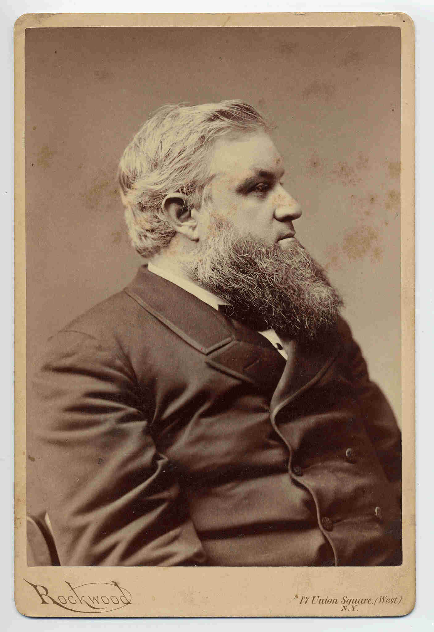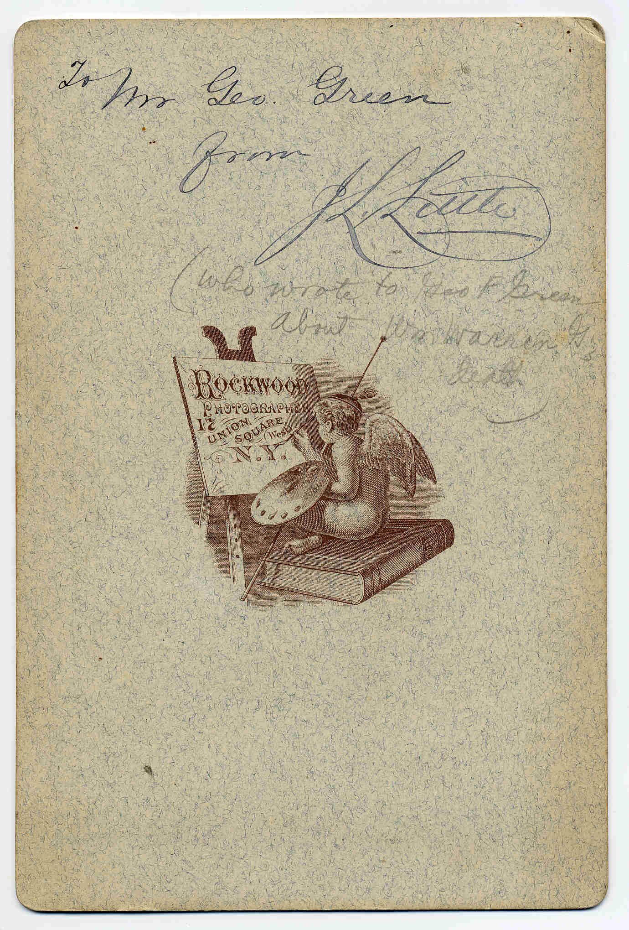

Mgcvtmd@aol.com wrote:
Stan,
After reading a little more about William Warren Greene, it appears as though he was James Little's equal with regard to both his skills and accomplishments. The International Medical Congress was indeed a prestigious affair. The annual event attracted the most famous names in medicine and surgery from the United States and Europe. The 1881 Congress was notable for the shift from surgical "cleanliness" (i.e. washing hands and instruments prior to operating; which in itself was still a novel concept at that time) to "antisepsis" (killing bacteria before they could enter a wound). Joseph Lister had been promoting antisepsis since 1867, but it took more than a dozen years for the rest of the world to catch up. Little attended in order to observe Lister's methods, which he subsequently adopted upon his return to New York and Vermont.

I have found two items online that should hold great interest for you. The first is a transcript of the presentation your great-great uncle made at the Congress regarding "cleanliness" and "antisepsis" as published in The Medical Record, one of the leading journals of the day: Medical record - Google Book Search (click on the arrow in the upper right corner to page through the document.

The second is a more detailed description of his worsening illness while in England and subsequent demise during the return voyage: Gaillard's Medical Journal - Google Book Search. He suffered from what was called Bright's Disease, a chronic inflammatory condition of the kidneys that has been largely eradicated today through the use of antibiotics. Back then, of course, it was uniformly fatal. The only up side to the disease was that the patient slipped into a coma at the end, and was thus unaware of his or her fate.

Well, on that happy note, thanks again for the markedly improved scan and permission to use it,

Michael

Michael, you've abundantly compensated me for the use of the J.L. Little scan. How nicely the day has worked out for both of us! Thanks for the links, and thanks for your explanatory notes, below. I'll share all with the family, including some of WWG's descendants.
- Stan

A transcript of William Warren Greene’s presentation at the Congress regarding "cleanliness" and "antisepsis" as published in The Medical Record, one of the leading journals of the day: Medical record - Google Book Search
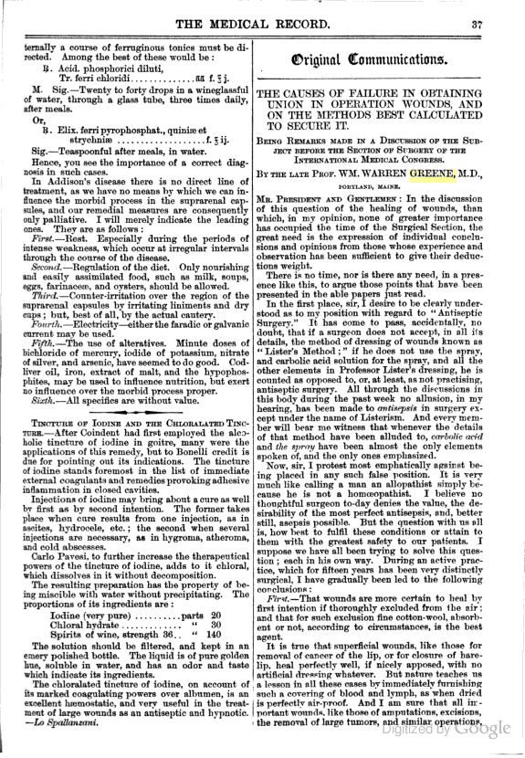

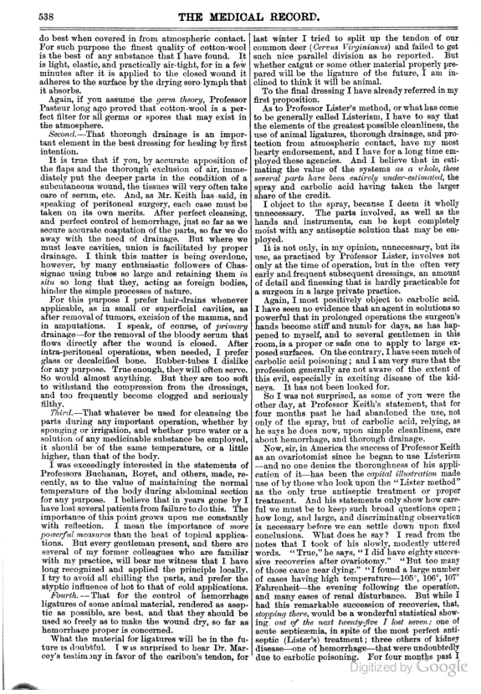

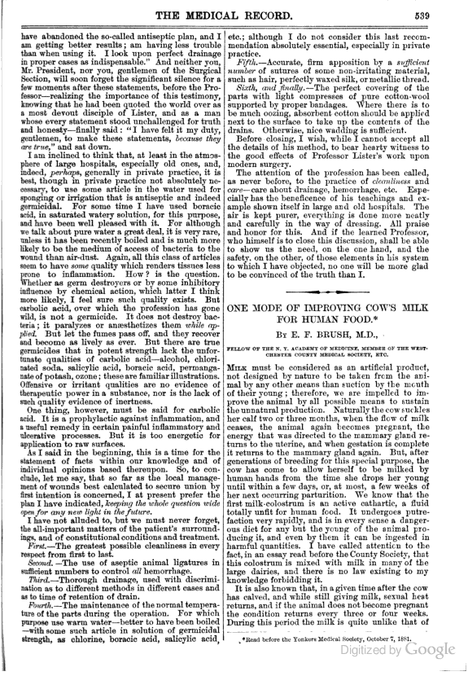

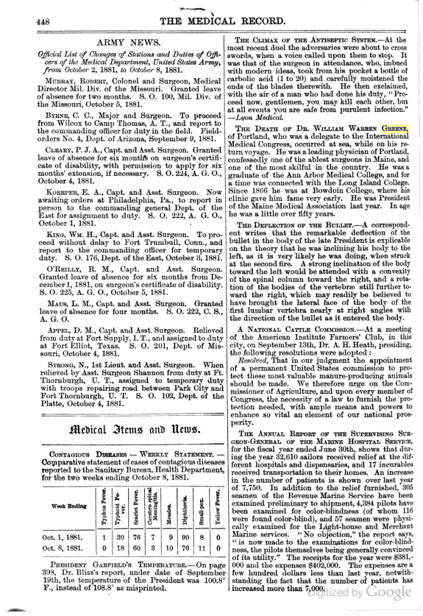

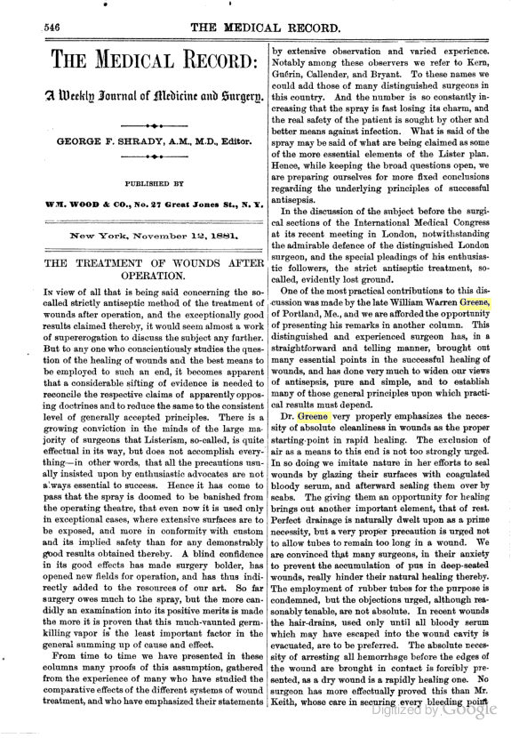

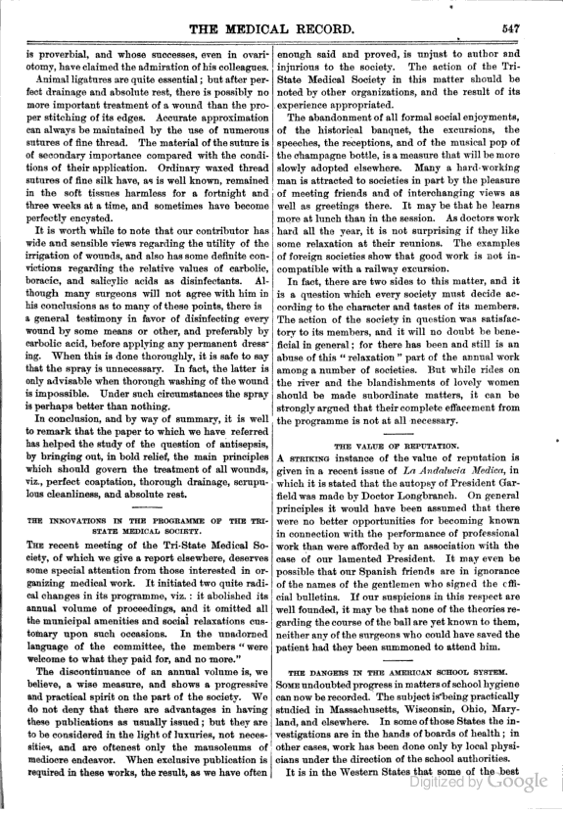

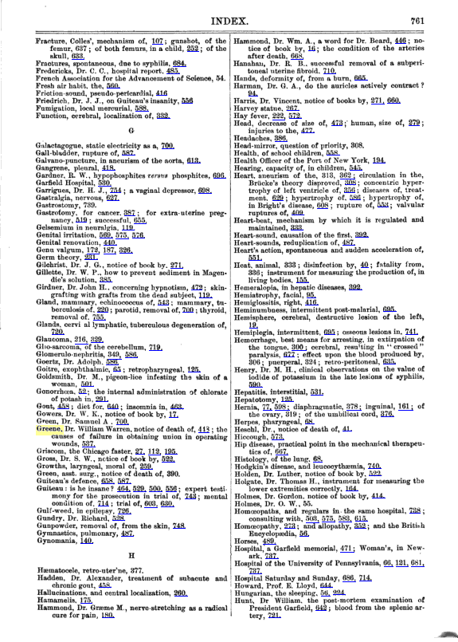

From Gaillard's Medical Journal - Google Book Search