Digital Kaleidoscope Workshop:
Learn to make kaleidoscopes using online images - by Stan Malcolm

Who doesn’t enjoy playing with a Kaleidioscope! Making your own at home is not for everyone, and purchasing a nice one can get expensive – plus there’s no good way to save that perfectly beautiful image, not even long enough to pass the kaleidoscope to a friend or family member so they can enjoy the view. Enter the digital world and easy to use web software that lets anyone “build” a kaleidoscope in a matter of minutes, then save the best views to computer files – for printing, posting on Facebook, or e-mailing.

Before | After
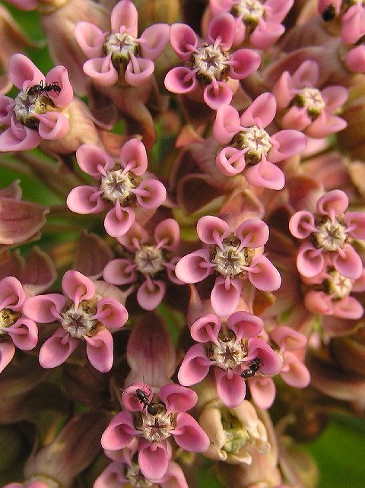 | 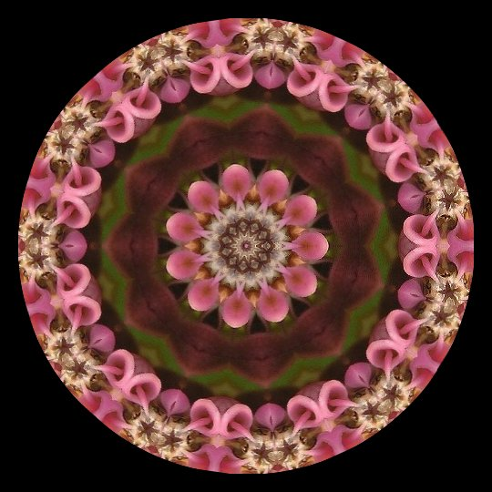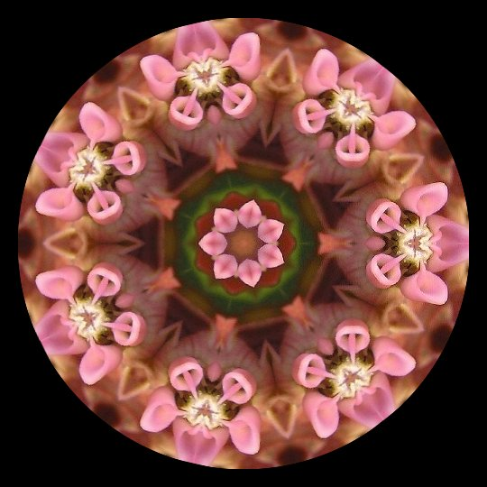

INSTRUCTIONS:
- Open up a browser window on your PC and go to Jim Bumgardner's "Make your own Kaleidoscope” software available free online at http://www.krazydad.com/kaleido/
- Open a second browser window and locate an image you like.
  - Hint: In Google, select “Images” then search for a subject you’d like to use (e.g., daisies; puppies; shells). Images 300 to 500 pixels wide seem best. Click on that thumbnail image to navigate to the original image on its web page.
  - OR… for practice, start with an image on one of my Air Line Trail pages, for example:
http://www.performance-vision.com/airline/airline-spring-05e.htm
- Right-click anywhere on your chosen image. Then if using Internet Explorer, select "Properties" from the drop-down menu, and copy the address (URL) that you’ll see listed in the pop-up. Then close the pop-up. If using Mozilla Firefox, simply select “Copy Image Location”.
- Now switch over to the Make your own Kaleidoscope browser window that you opened earlier.
  - Hint: Have a look around. You’ll see a space to enter a URL (it comes up with a test image already loaded) and next to that a button labeled “Load”. You’ll also see buttons labeled “JPEG” and “Feed”. Towards the upper left there are three colored “circles” divided into 7, 11, and 5 pie-shaped sections. If you scroll down, you’ll find instructions that explain everything.
- Now, paste the URL you copied into the space provided and click "Load". Then click and drag your mouse over the “ghost image” to start the magic. Try the 5-way (default), 7-way, and 11-way options.
- When you see something you especially like, click the JPEG button to capture the image. (It takes a moment to work.) Right-click on that image, select "Save image as...", give it a name and Save it on your computer.
- Click your browser’s back button to return to the Kaleidoscope creation page. Once there, you’ll have to Load your URL again (or load a different image’s URL) to begin creating another Kaleidoscope.
- PRINTING: The images you create are fine for on-screen display or for small prints (e.g., up to 4x4”). If you want to print larger versions you’ll have to use image editing software to multiply the number of pixels. This tends to increase digital “noise” which you can reduce (but probably not eliminate) using imaging software. I limit my prints to 8x8” which I find acceptable for viewing when framed. NOTE: People will ask what image you started from. If you own the image, you can print that out and frame it with your Kaleidoscope. Please do not print images found on the web without the photographer’s permission. That would be violating copyright. You may print images from my pages up to 4x6” for private, non-commercial use.

Have a look at samples of my captures:
http://www.performance-vision.com/Kaleidoscopes/index.htm
http://www.performance-vision.com/Kaleidoscopes/index2.htm

